* Pytest execution screen print

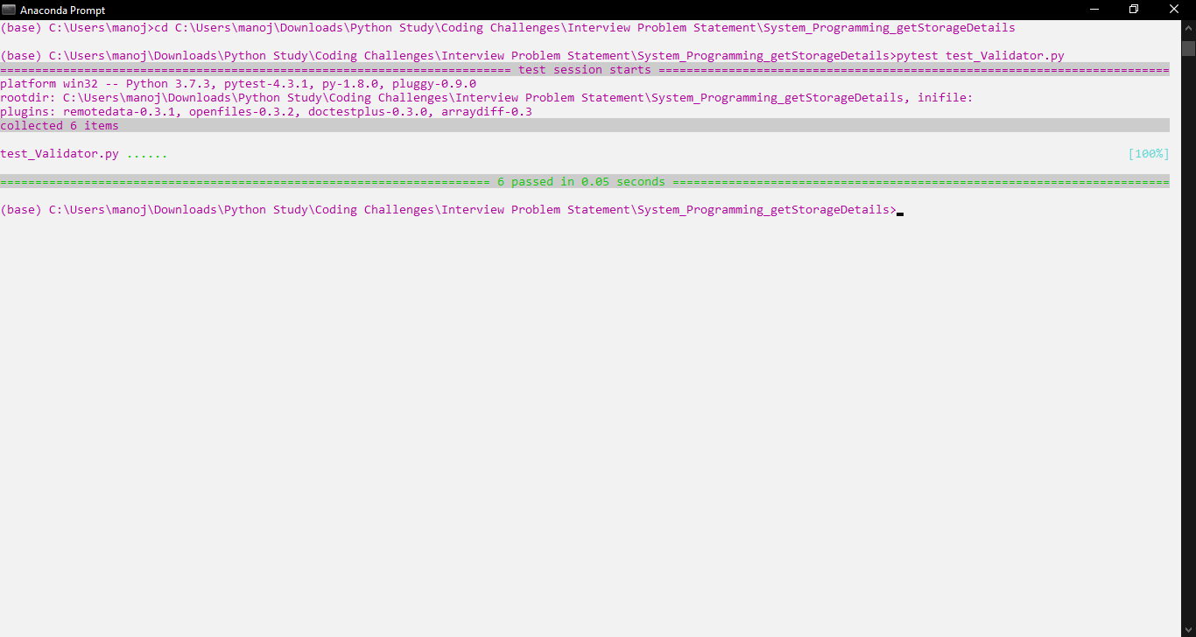

* Jenkins Run Log -> Windows Test Case

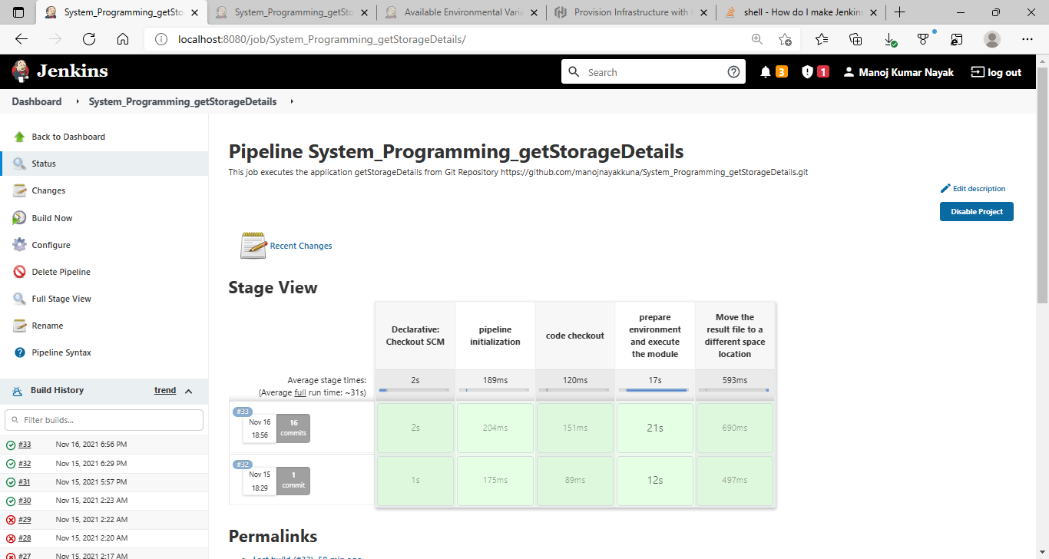

* Docker’s Container Run Instance For Linux Jenkins

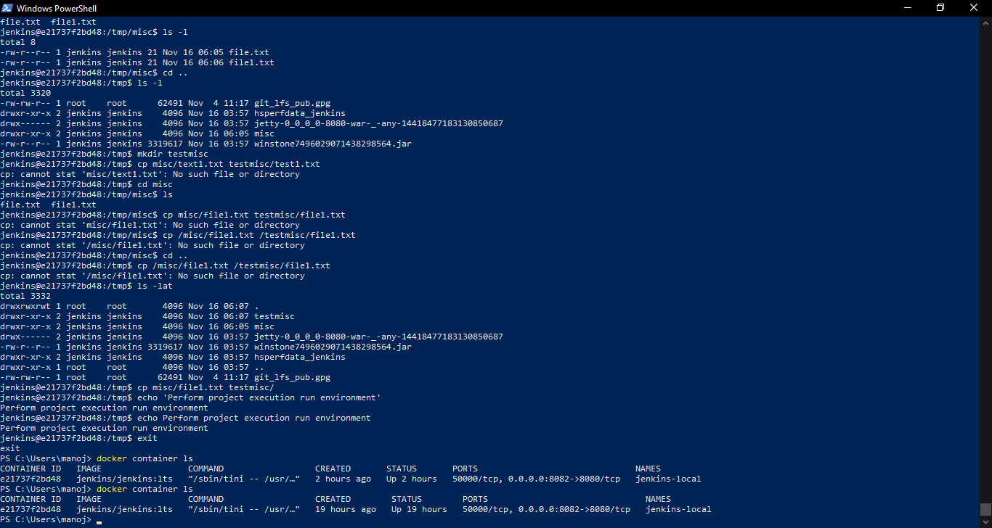

* Jenkins From Linux Instance Running From Docker Container